**Task 1:**

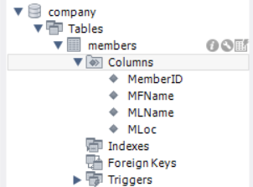Create the following tables: Members

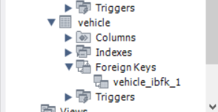Vehicle:

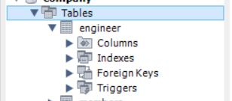Engineer:

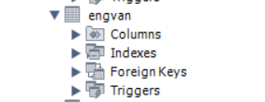EngVan:

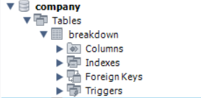Breakdown:

Using the Alter command set the foreign keys

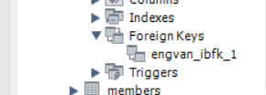

**Task 2**

Enter the following data

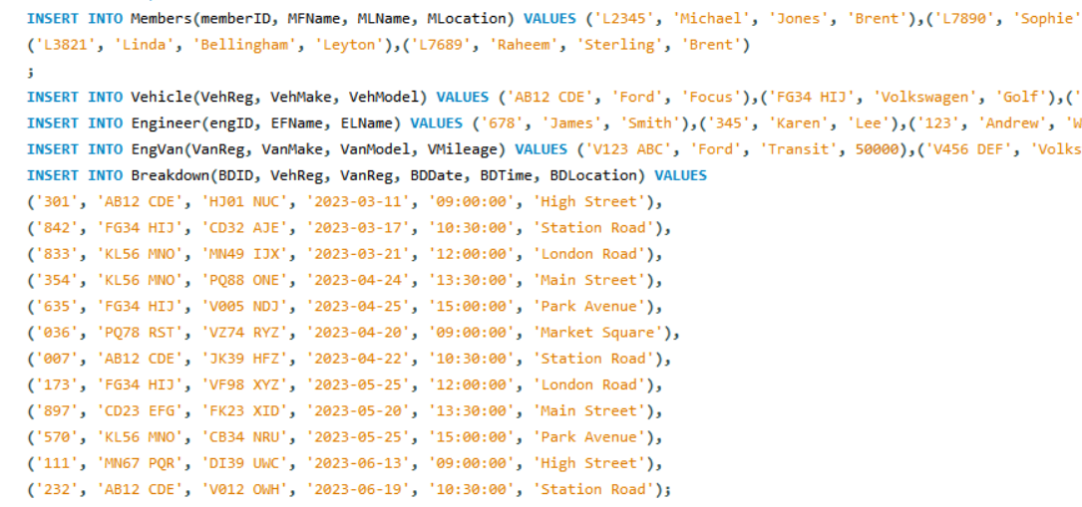

**Task 3**

Perform the following queries

1. The names of members who live in a location e.g. London.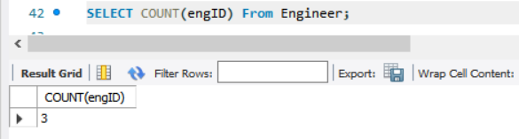

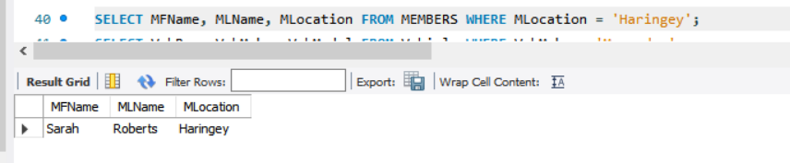

1. 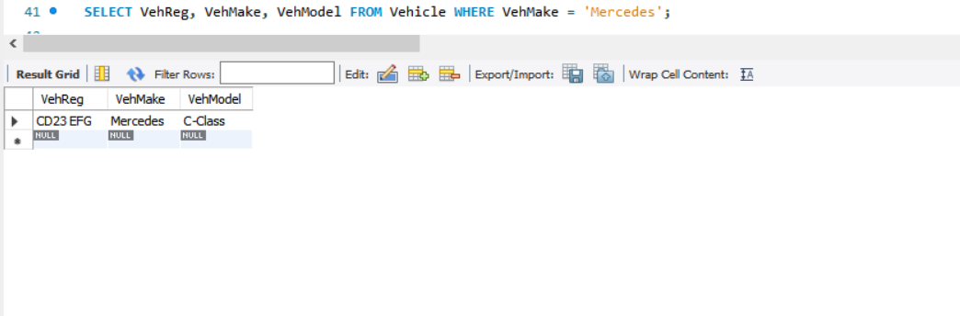All cars registered with the company
2. The number of engineers that work for the company.
3. The number of members registered.

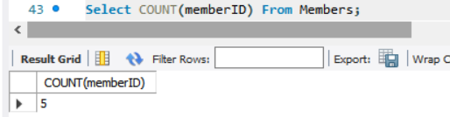

1. All the breakdown after a particular date.

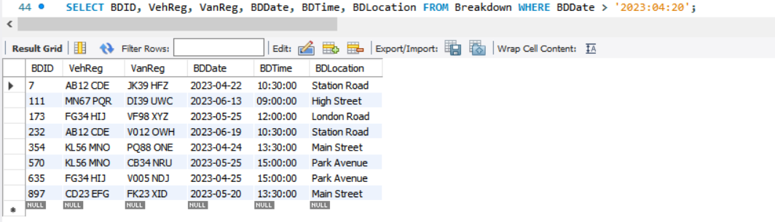

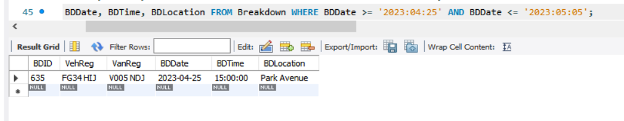6.All the breakdown between 2 dates.

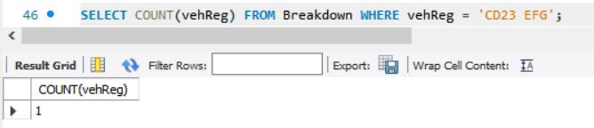7.The number of time a particular vehicle has broken down.

8. The number of vehicles broken down more than once.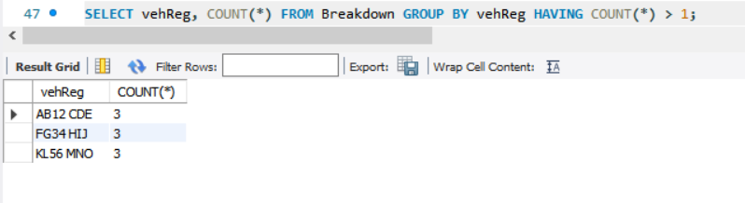

**Task 4**

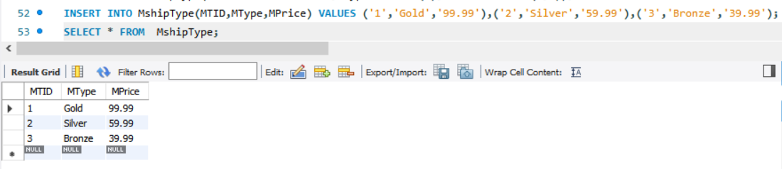Create the following table: MshipType:

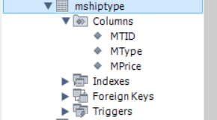

**Task 5**

Using the alter command add in the field “MTID” in the members table, set it to FK and allow null. Then using the update command assign a MTID to each vehicle.

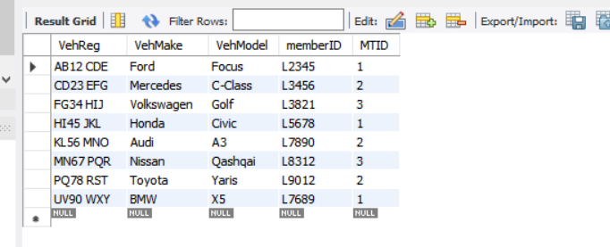

**Task 6**

Perform the following queries:

1. 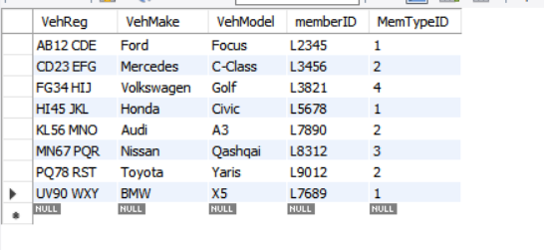All the vehicles a member owns.
2. The number of vehicles for each member in descending order.
3. 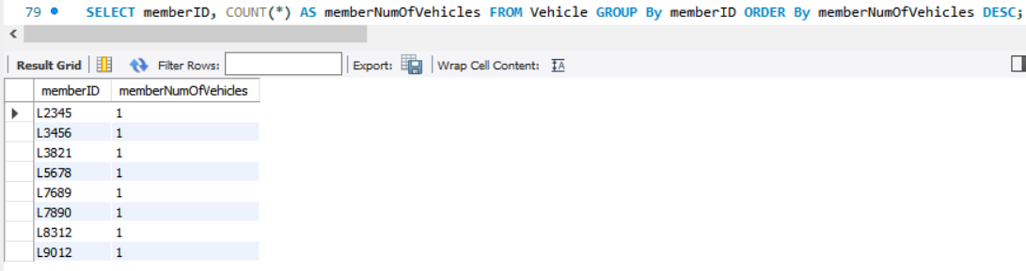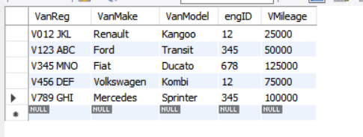The number of vans driven 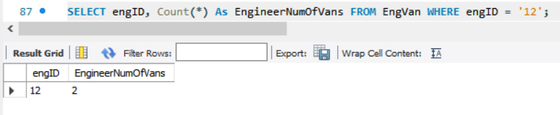by a particular engineer.
4. 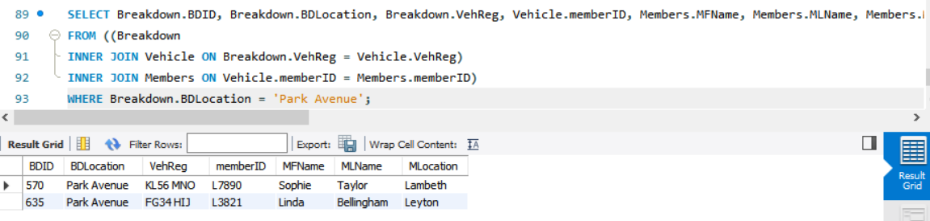All vehicles that have broken down in a particular location along with member details.
5. 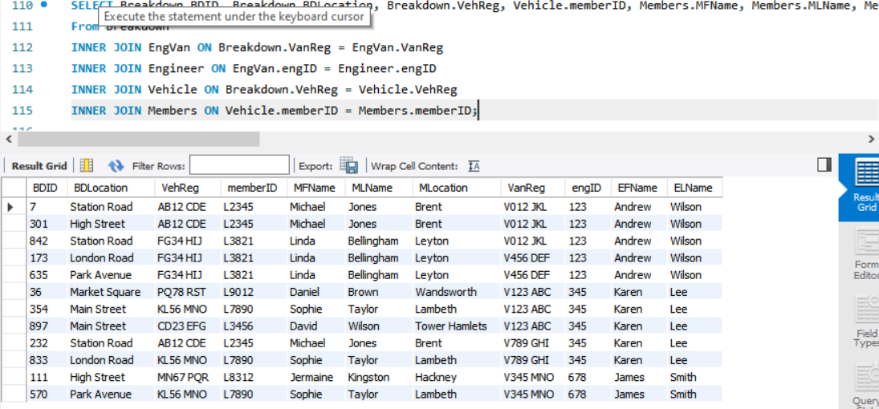A list of all vehicles that broke down along with the member details and the engineer who attended.
6. 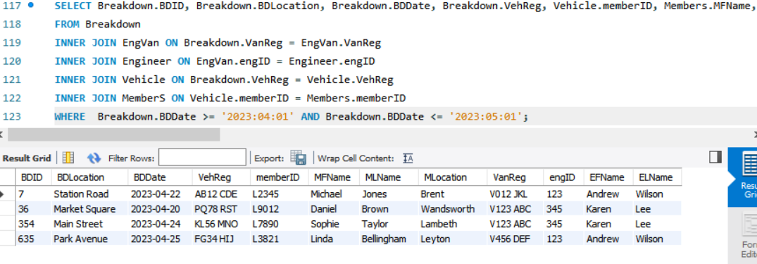A list of all breakdown along with member and engineer details between two dates.
7. A further 3 relational queries of your choice that are meaningful to the company.

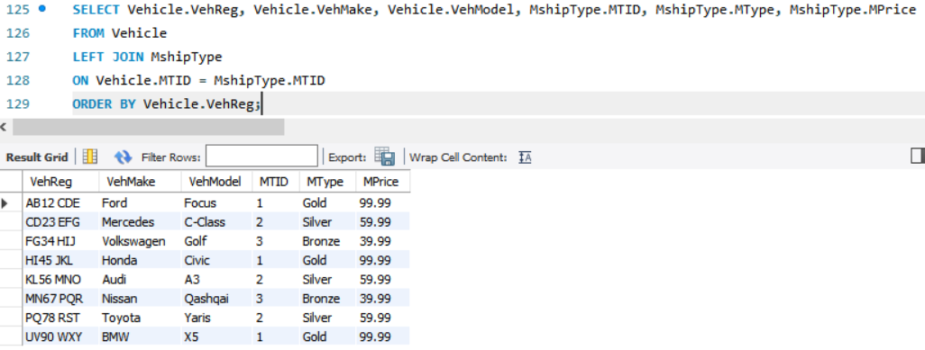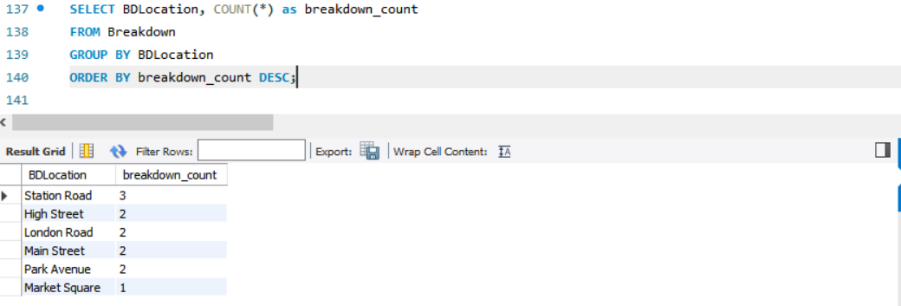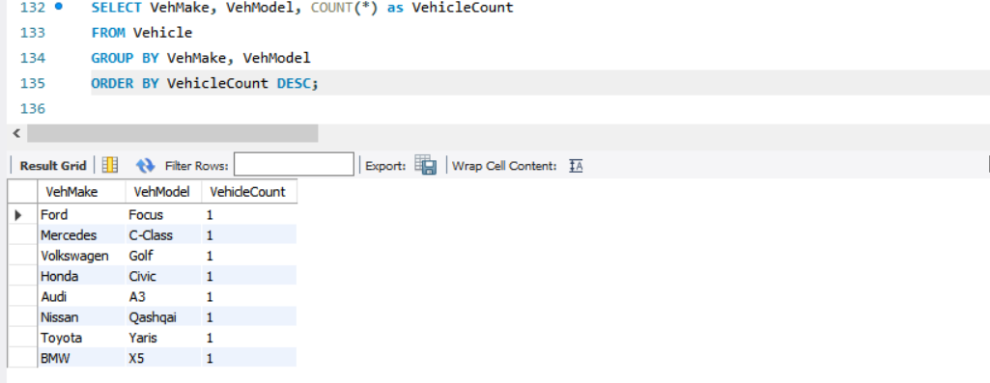

**Task 7**

Using W3Schools or any other resource research the following functions – Avg, Max, Min, Sum. Explain with examples how each one is used. Create a separate database with sample data to illustrate your examples. However please do not copy from the websites.

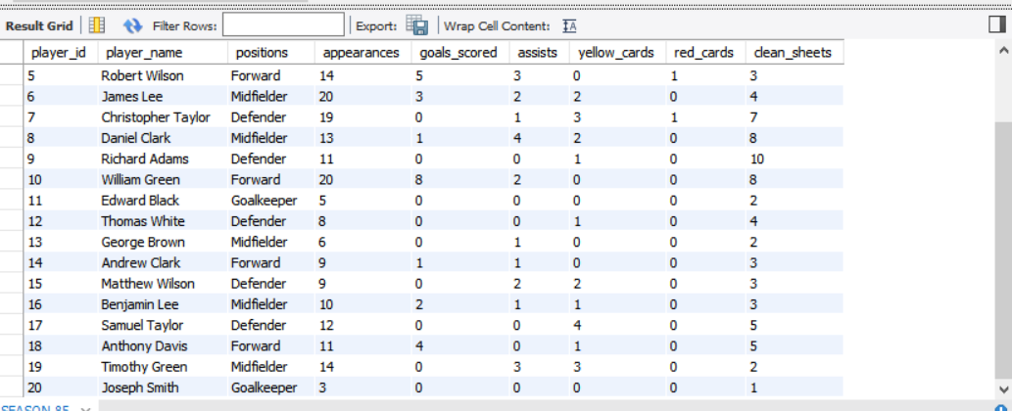1.Created a stats table for a football team

2.Average of goals scored from this season.

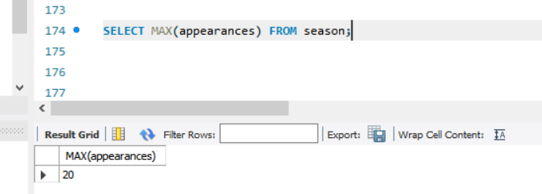3. The MAX function is used to find the maximum value of a column in a table,Max appearances from this season 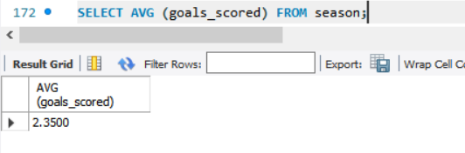

4.The MIN function is used to find the minimum value of a column in a table, Minimum number of assists this season.

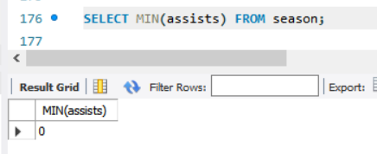

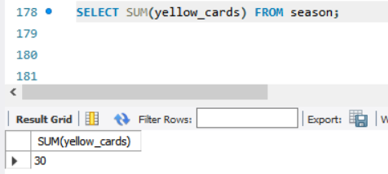5. The SUM function is used to calculate the total of a numeric column in a table. Sum of yellow cards the team acquired this season.

**Task 8**

1. For 2 can say if greater than one vehicle owned then has multi-car policy

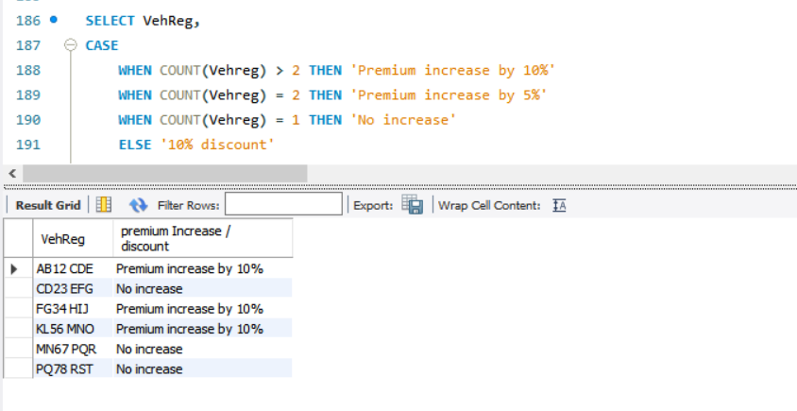

1. The number of times each car broken down
   1. If more than twice then next premium to be increased by 10%
   2. If twice then increase by 5%
   3. If once then no increase
   4. If not broken down then 10% discount

